Leviticus I Offerings and Sacrifices for Christians

Last two weeks:

We learned two things from these Jewish festivals:
1. God wants us to party—to take time to stop working, and to enjoy the simple pleasures of having a relationship with him! (The Christmas holiday is a great opportunity for that)
2. Beautiful symbolism. Amazing Bible-inspiration-proving prefigures and foreshadows in these festivals of New Testament realities.
We learned about the seven chief Jewish festivals in the Old Testament, and what they teach us about God, and about the blessings we have through Jesus:

Passover: We celebrate that Jesus us our Passover Lamb
Firstfruits: We celebrate the resurrection of Jesus and that he is the firstfruits from the dead and assurance of our future resurrection.
Unleavened Bread: We celebrate that we have been purified from all sin.
Pentecost: We celebrate our spiritual birthday and that we have received the Holy Spirit.
Trumpets: We prepare for the second coming of Jesus.
Day of Atonement: We celebrate that Jesus is the atoning sacrifice for our sins.
Feast of Tabernacles: We celebrate that God dwells among us in the Holy Spirit.

Last week: Hanukkuh The Feast of Dedication.

Celebrating the rededication of the temple after its desecration by Antiochus Epiphanes.

As with the others, Hanukkuh points toward Jesus.

Our temple was desecrated.

We needed Jesus to rededicate our temple so that the Holy Spirit—God’s light could come and dwell within us again.

This week: Leviticus I Offerings and Sacrifices

Most disciples get a glazed-over look when reading in Leviticus about all the different sacrifices, ceremonies, festivals, laws and so forth.

Theme: The seriousness of sin and the need for sacrifice. In a word: Holiness.

Theme verse: Leviticus 11:45 I am the Lord who brought you up out of Egypt to be your God; therefore be holy because I am holy.

Expanding on this: Lev 18:1-5 You must not do what they do in Egypt or in Canaan. v. 5 “The person who obeys them (these laws) will love by them. I am the Lord.

Let us think about our holiness.
Let us think about our separateness (which is the meaning of holiness) as Christians from the world.
Let us think about our differentness from the world.

Let’s break it down:

Ch 1-7 The five main sacrifices
Ch 8-10 The Levitical Priesthood
Ch 11-22 The Laws of Moses
Ch 23-25 The Sabbath and Festivals
Ch 26 Punishment and Reward
Ch 27 More laws.

The one major part of the Law of Moses not in Leviticus is the instructions for building the Tabernacle. We covered this in Exodus.

We have also covered the festivals as part of Exodus.

Today: The Sacrifices

Next: The priesthood and the Law.

Ch 1 The Burnt Offering.
Ch 2 The Grain Offering.
Ch 3 The Fellowship Offering.
Ch 4,5 The Sin Offering.
Ch 5,6 The Guilt Offering.

Not all the sacrifices in the Levitical system were for forgiveness of sin!! In fact, many of them are more rightly called gifts and offerings.

- Sweet-smelling sacrifices. “An aroma, pleasing to the Lord.” Were not for sin. There is nothing sweet smelling about sin!

  - The Burnt Offering (olah)
  - The Grain Offering (minchah)
a. The Drink Offering (nesek)
  - The Fellowship Offering (shelem)

- The sin sacrifices.

  - The Sin Offering (chatat)
  - The Trespass Offering (asham)

The former are worship of God, while the latter make it possible for us to worship God in the first place.

a. Priests offered gifts and sacrifices. What are those gifts and what do they prefigure? What are those sacrifices and what do they prefigure?

Hebrews 5:1 “Every high priest is selected from among men and is appointed to represent them in matters related to God, to offer gifts and sacrifices for sins”

The Burnt Offering. (olah) = Total commitment of the worshipper (us!) Leviticus 1 A pleasing aroma.

Leviticus 1:3-13

“It is a burnt offering, an offering made by fire, an aroma pleasing to the LORD” (Leviticus 1:13).

God: Take a valued possession and burn it up on the altar. Once you burn up something, there is no getting it back.

This offering was voluntary.

Animal from the herd. A bull or a sheep or, if you were poor, a bird could be offered. This symbolizes that what you give will be in proportion to what God has blessed you with, but all ought to make this commitment.

Take the animal and lay your hands on the animal. Symbolically identifying the animal with yourself.

Then the body was thoroughly cleaned, inside and out, but the head was not, then the entire thing was burned on the altar. At the end, nothing was left except a tiny pile of ashes.

Why? The head is Jesus (Eph 1:22-23), we are the body. We need washing. Both us and Jesus are expected to make a total sacrifice of ourselves.

Ephesians 5:1,2 (read it) Jesus offered himself as a burnt offering. “a fragrant offering.”

He gave himself as an offering while he was still alive. This was his act of worship. Q: What did Jesus hold back?
Did he have to do this? Was he saved by doing this? Were we saved by his doing this?

Romans 12:1,2 “in view of God’s mercy.”

Our lives are offered voluntarily as burnt offerings as well. We offer ourselves, not in order to be saved, but as a response because we are saved.

It’s up to you. But “in view of God’s mercy” will you not present your life itself as an offering?

Phil 1:20-22 I eagerly expect and hope that I will in no way be ashamed, but will have sufficient courage so that now, as always, Christ will be exalted in my body, whether by life or by death. For me to live is Christ and to die is gain. If I am to go on living in the body, this will mean fruitful labor for me.

Is that the focus of your life?

Are you presenting your life right now as a living sacrifice to God?

Isaiah 6:8 Whom shall I send? Isaiah: Here am I, send me.

Are you taking things the world thinks you ought to reserve to yourself and burning it up on the altar? When was the last time we heard about someone selling everything and going on the mission field? When was the last time we heard about someone selling their vacation home and laying the money on the “altar?” Have we lost the spirit of the NT church?

Brothers and sisters, let us decide today to make a voluntary burnt offering (olah) to God. What will your offering be?

The Grain Offering = giving of the first fruits of our labor to God.
A pleasing aroma.

Leviticus 2:1-3, v. 11-16 “an aroma pleasing to the Lord” (Leviticus 2:3)

Not voluntary

From first fruits (v. 14) of what God blesses us with. (God wants our best, not our leftovers)

Grain, oil, incense and salt, but definitely no yeast or honey.

Part burned, part given to take care of the Levites. (Lev 2:3,10)

Give of the blessings of God to take care of the Temple and the servants of God.

Give of first fruits. Not the left-overs. Used clothes? Starbucks card with $1.46 on it. Our leftover time?
Reminds us that our blessings come from God.

Grain = fruit of hard, sustained labor. When we give to God it costs us something. It should hurt!

Oil (v. 1) = Joy Hebrews 1:9 The oil of joy. 2 Cor 9:6-7 God loves a cheerful giver

Incense (v. 2) ( prayer 2 Cor 9:12-14) (also Luke 1:10 at the hour of incense all were praying, Rev 8:3 a large amount of ince nse to offer with the prayers of all the saints Rev 5:8 bowls of incense which are the prayers of the saints.)
Our offering should be brought with prayer.

Salt (v. 13) (eternal blessings Matthew 5:13 You are the salt of the earth. The preservative Coll 4:6 Let your conversation be full of grace, seasoned with salt 2 Chron 13:5 Numbers 18:19 a perpetual covenant of salt)

No yeast (v. 11) (yeast = sin and hypocricy. 1 Cor 5:6-8). An offering tainted with greed or bad motives is better left out of the plate.

No honey (v. 11) (honey signified for the Jews things which decay)

Note: Leviticus 2 does not actually mention 10%, but we know from other contexts that it was in fact a “tithe.” Leviticus 27:30-32.

The giving of a tithe was the minimum expected so that the people would remain ceremonially clean and so that God would bless the people.

= Our contribution for the needs of the church and of those who minister to the church. 2 Cor 8,9

Giving to the needs of the local church is not optional, but the extent of giving is, “for God loves a cheerful giver” (2 Corinthians 9:7). Paul associates prayer (incense) with the offering (2 Corinthians 9:12,14) as well as eternal blessings (salt) (2 Corinthians 9:6-11).

Malachi 3:7-10 For ancient people, the giving of a 10th was a contract that the government would protect the people.

Do you want the blessings? 2 Cor 9:6 A man who sow sparingly will reap sparingly. A man who sows generously will reap generously.

Let’s face up to the 10% issue. It is NOT a NT teaching, but Jesus did say that “unless your righteousness exceeds that of the Pharisees…
Matthew 5:20.

Definitely not just giving what is left over.

Summary:
Our contribution to the Lord should:
1. Come as the first fruits of hard work. It should be sacrificial. It should hurt.
2. Given joyfully (the giving is not voluntary, but the amount is)
3. Be offered with prayer
4. Will produce eternal blessings
5. Should come from a pure, unblemished heart.

The Drink Offering (nesek) = pouring out our life in devotion to God.

Exodus 29:41 a grain offering and a drink offering with it, Leviticus 23:13 and Numbers 28:31 for example

Usually given with the grain offering. The connection is significant. We give our 10%, but we also pour out our lives.

At the end of the day/life, there is nothing left. It is all poured out.

Jesus made a drink offering: Luke 22:20 “Which is poured out for you.”
Isaiah 53:12 Jesus poured out his life.

Paul made a drink offering: (Philippians 2:16,17) 2 Tim 4:6-8

Are you pouring out your life or are you holding things back in the cup?

My wife Jan is a great example of this. She pours everything out.

What are you saving for? Where are you putting your treasures?

Are you “All in?” Have you poured yourself out?

Summary:
God wants us to give our lives as sweet-smelling offerings to him.

1. He wants us to be a burnt offering. To offer our lives as a living sacrifice.

2. He expects us to give a grain offering—a sacrifice from the first fruits of what we have earned to support the work of God.

3. God wants us to pour our lives out as an offering on the altar—in addition to our required grain offering.

The Fellowship Offering (peace offering) Leviticus 3 = Celebrating the blessings of having a relationship with God. A pleasing aroma.

Voluntary. A way to spontaneously celebrate some sort of blessing from God.

Three types of fellowship offerings:

Vow-offering (Lev 11:16, 22:23) given in anticipation of a future blessing

Thank-offering (Lev 7:11-15) given in response to a specific blessing

Free-will offering (Lev 22:23) just fired up about God and giving an offering

Sacrifice an animal, sprinkle blood on the altar, burn the kidneys, fat and entrails, then have a party sharing the meat together with friends.

Purpose: To celebrate the blessings of having a relationship with God.

Remember: This is part of our worship.

Sacrifice made, party happens, all must be finished that day.

Foreshadow: We should take the time to celebrate on a daily basis the great blessings we have in God. Do we need to remember to celebrate the little things? Do we tend to forget the little blessings.

One big theme in the OT we tend to miss. They had a lot of parties. God was constantly telling them to celebrate, to party, to rest, to simply enjoy a relationship with God. God wants us to be happy. The blessings of being saved are awesome—amazing. Do you celebrate these things on a regular basis. Small parties, big parties, private parties,

Eph 1:3 Every spititual blessing in this life!

The NT equivalent:

1 Thess 5:16 Rejoice always (free-will) Pray constantly (vow-offering) give thanks in all circumstances (thank-offering)

This is part of our worship. Christianity is not just about sacrifice and suffering. It is also about wonderful blessings.

One interesting fact about the fellowship/shelem offering is that it was often placed on top of the burnt offering/olah sacrifice. This indicates that the blessings of God are based on and produced through our dedication to him. The greater the devotion offered, the greater the blessing given by God. It is not that our good deeds and sacrifices to God earn the blessings. The New Testament makes it clear what we deserve based on our sin. Our devotion does not earn the blessings, but that is just how God works. The blessings are the natural response of God to our sacrifice to him.

Sacrifices for sin/blood offerings

Heb 9:13-14 The blood of goats and bulls and the ashes of a heifer sprinkled on those who are ceremonially unclean sanctify them so that they are outwardly clean. How much more, then, will the blood of Christ, who through the eternal Spirit offered himself unblemished to God, cleanse our consciences from acts that lead to death, so that we may serve the living God!

The sweet savor sacrifices are foreshadows of our worship of God (and Jesus’)

These are never called a sweet savor. They are a foreshadow of the redemptive work of Jesus Christ. Bottom line, we have a sin problem separating us from God. These sacrifices are about the sacrifice of Jesus for forgiveness of sins.

Before looking at the two sacrifices, one note.

These sacrifices did not and were never intended to cover intentional sin.

Leviticus 4:1 (read it… talking about the sin offering) 4:13-14 When Israel or an individual sins unintentionally.

What about intentional sin? Hebrews 10:26-31 Deliberate sin is a problem, even for us. Be careful.

Sin Offering (chatat) Lev 4:1-5:13

In general, for offenses against God’s authority or territory.

Guilt Offering (asham) Lev 5:14-6:7

In general, for offenses against a fellow Israelite. (Psalm 51 Against you only have I sinned?)

God saw sins against him and sins against our brother as equal.

The details.

The Sin Offering:

The sin offering had to be an unblemished animal (Jesus was unblemished)

The offender laid their hands on the animal. (our sin was laid on Jesus The Lord laid on him the iniquity of us all)

Isaiah 53:6, “and the LORD has laid on him the iniquity of us all.”

The offender actually killed the sacrifice. (God made this Jesus whom you crucified, brought home the seriousness of the offense. Offender sees the blood flowing on the ground is likely to remember the seriousness of the sin. Are you remembering the price paid for your sin?

The words of the people in the crowd when Jesus was condemned speak volumes for us. “Let his blood be on us and on our children” (Matthew 27:25).

Blood sprinkled at the curtain in the temple and around the altar. Kidneys and fat burned on the altar, the body was carried outside to be burned. (Jesus was carried outside Jerusalem to be killed) (Hebrews 13:11-13)

The high priest carries the blood of animals into the Most Holy Place as a sin offering, but the bodies are burned outside the camp. And so Jesus also suffered outside the city gate to make the people holy through his own blood. Let us, then, go to him outside the camp, bearing the disgrace he bore (Hebrews 13:11-13).

Guilt Offering (asham) Leviticus 5:14-6:7

Similar to Sin Offering, but

1. There was no such thing as an offering for a group sin. Only individual sins against each other were atoned for. The point: we are to take personal responsibility for our sins against one another

2. The offender had to make restitution to the person offended before bringing their sacrifice to the priest. (Matthew 5:23,24)

Isaiah 53:10, that, “it was the LORD’S will to crush him and cause him to suffer, and though the LORD makes his life a guilt offering, he will see his offspring and prolong his days.” When God made Jesus a guilt offering, he had in mind “his offspring,”

“God made him who knew no sin to be sin for us, so that in him we might become the righteousness of God” (2 Corinthians 5:21).

Remember, though, that God wants us to rest confident in the efficacy of the saving sacrifice of Jesus Christ. Let’s finish with Heb 10:19-22:

Therefore, brothers, since we have confidence to enter the Most Holy Place by the blood of Jesus, by a new and living way opened for us through the curtain, that is his body, and since we have a great priest over the house of God, let us draw near to God with a sincere heart in full assurance of faith, having our hearts sprinkled to cleanse us from a guilty conscience and having our bodies washed with pure water.

These are never called a sweet savor. They are a foreshadow of the redemptive work of Jesus Christ. Bottom line, we have a sin problem separating us from God. These sacrifices are about the sacrifice of Jesus for forgiveness of sins.

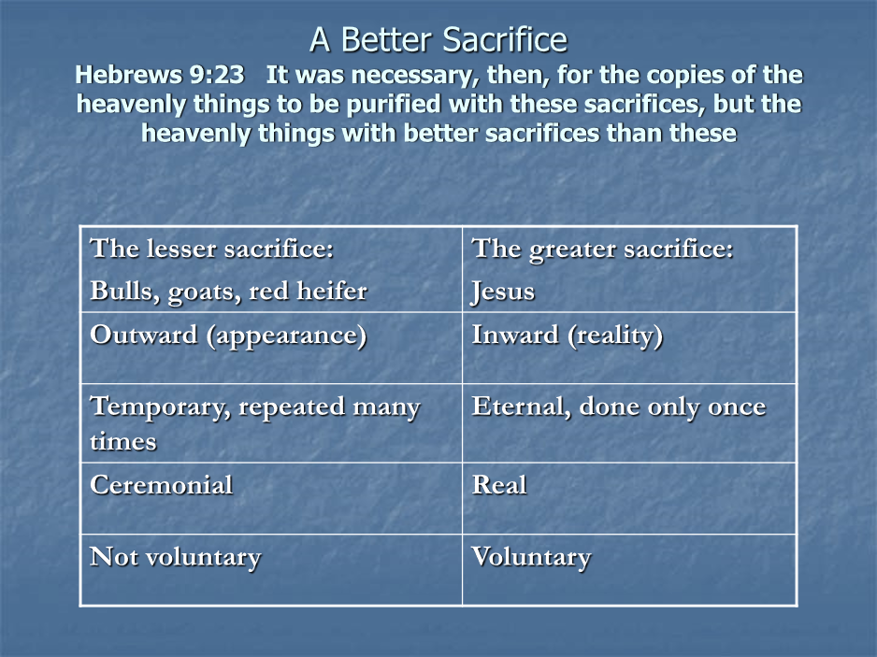

Aside:

The Jews has another sacrifice which might even have preceded the Levitical system. This is the Red Heiffer Sacrifice. Hebrews 9:13.

Numbers 19:1-22. A sacrifice for ceremonial cleanness “the water of cleansing.” Use for those who had touched dead bodies and for certain skin diseases v. 16-18.

Parallels/ Prefigures between the Red Heifer and Jesus Christ:

1. A very rare red heifer A unique son
2. Sacrificed outside the camp Sacrificed outside the camp
3. To purify both Jew and Gentile To purify both Jew and Gentile
4. A sacrifice without blemish A sacrifice without blemish
(without even a single black hair)
5. Never been yoked A volunteer sacrifice
6. Scarlet wool and wood Blood on wood
7. Hyssop (for purification from Purifies from the effects of sin
the effects of death)
8. Ashes plus water for purification Blood and baptism for purification

